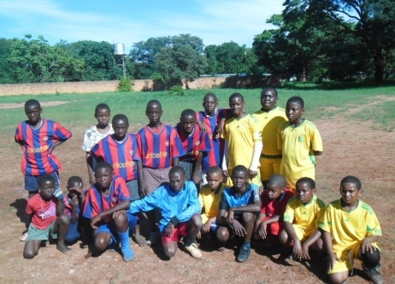


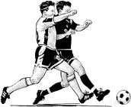
RULES, REGULATIONS AND RESPONSIBILITIES

COMMUNITY STREET SOCCER CHAMPIONSHIP
HOSTED BY: BLUE STARS UNITED ACADEMY

THREE A-SIDE COMPETITION
PRIZES: CASH PRIZE AND TROPHY
AGE GROUP: 10YEARS – MADALAS
REGISTRATION FEE PER PERSON (K2) KIDS AND (K5) ADULTS
VENUE: NYUMBA YANGA COMMUNITY GROUND
DATE: 9th December 2013 TIME: 9HRS TO 1730HRS
FOR MORE INFORMATION CONTACT NUMBER +260979342768


REGISTRATION IS DONE AT CROSSROAD’S EVERY SATURDAY’S
IT’S HERE, BIGGEST STREET SOCCER COMPETITION

Players:
- All documents will be checked before and after team registration and before and after the games.
- All teams should be with three players each only. For it’s a three A- Side game.
Duration of Games and Game Ball:
- Games shall be 10 minutes as applicable
(5 minutes for each half).
- Half time for each game is 2 minutes.
- No additional time.
Substitutions:
- There are no Substitutions.
Ball out of Play:
- There is no thrown INS.
- There are no offsides.
- There are no high balls.
- There are no goal kick
- There are no corners.
Tournament Game Rules and Fouls:
- Prayer before and after the games.
- FIFA rules will be enforced unless stated differently.
- All players should be in team colour
- Penalty kicks shall be placed at a distance of 3-feet from the goal.
- Opponents must line up 10 feet from any free kick.
- Yellow Card: a player will miss one game. And if given a second yellow card to a player in the same game becomes a red card then will miss two games. (a red card you miss two games)
- Slide tackling will not be allowed.
- There will be coin flip for each game. Who to start the game.
- All play of the game will be played down ball game.
- When each team holds position it gets one point only and added to the goals.
- When a ball is kicked high it’s a free kick to opponents.
- Fair play and always play with a whistle.

Referee:
- The referee will be in charge of the game and should know the rules of the game
- The referee will always be outside the field to control the game.
- The referee will always read the rules of the game all the time before the match starts.
- The referee will work hand in hand and help the recorder over a team when it holds position to give it a point.
- The referee will work hand in hand with the person encharge of goal, point’s recorder.
- The referee should always be fair in all the games.
Standings:
- Ranked by points: Win-3 points, Tie-1 point, Loss-0 points
- Tie-breaking procedure:
- Winner of head to head game
- Goal differential. (Maximum of 3 per game)
- Fewest goals allowed
- Most games holding opponent scoreless
- Most games scoring at least more then 1 goal
- Coin flips.
Protests:
- Protests are not allowed. If you protests then 3 points is given to opponents.
Note: -
1).A Team which wins the championship it automatically books a place in a next championship which means they don’t need to pay any registration fee.
2).A wining team keeps the trophy for three weeks and then hand over to the management for the next championship.
3).A team as to win consistence (three times) then the keep the championship trophy for good.
4).The championship will only be played on holidays’.

