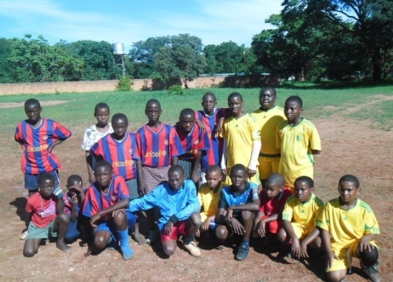
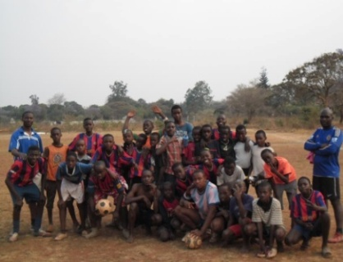
REGISTRATION FORM

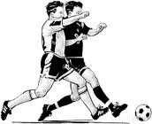
COMMUNITY STREET SOCCER CHAMPIONSHIP
HOSTED BY: BLUE STARS UNITED ACADEMY

THREE A-SIDE COMPETITION
PRIZES: CASH PRIZE AND TROPHY
AGE GROUP: 10YEARS – MADALAS
REGISTRATION FEE PER PERSON (K2) KIDS AND (K5) ADULTS
VENUE: NYUMBA YANGA COMMUNITY GROUND
DATE: 9th December 2013 TIME: 9HRS TO 1730HRS
FOR MORE INFORMATION CONTACT NUMBER +260979342768


REGISTRATION IS DONE AT CROSSROADS EVERY SATURDAY’S
IT’S HERE, BIGGEST STREET SOCCER COMPETITION

REGISTRATION FORM
No | Name | Team colour | Cell Number | Age | Signature
 |  |  |  |  | 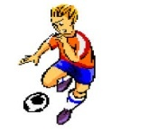

IT’S HERE, BIGGEST STREET SOCCER COMPETITION
GROUPING
COMMUNITY STREET SOCCER CHAMPIONSHIP
HOSTED BY: BLUE STARS UNITED ACADEMY
THREE A-SIDE COMPETITION
PRIZES: CASH PRIZE AND TROPHY
AGE GROUP: 10YEARS – MADALAS
REGISTRATION FEE PER PERSON (K2) KIDS AND (K5) ADULTS
VENUE: NYUMBA YANGA COMMUNITY GROUND
DATE: 9th December 2013 TIME: 9HRS TO 1730HRS
FOR MORE INFORMATION CONTACT NUMBER +260979342768
REGISTRATION IS DONE AT CROSSROAD’S EVERY SATURDAY’S
IT’S HERE, BIGGEST STREET SOCCER COMPETITION

Under 9-10 Groups 6 team’s per group from (A – G)
Group A (Gp) | Team colour | Team Captain | Win | Draw, Loss | Pts
Group B (Gp) | Team colour | Team Captain | Win | Draw, Loss | Pts
Group C (Gp) | Team colour | Team Captain | Win | Draw, Loss | Pts
Group D (Gp) | Team colour | Team Captain | Win | Draw, Loss | Pts
Group E (Gp) | Team colour | Team Captain | Win | Draw, Loss | Pts
Group F (Gp) | Team colour | Team Captain | Win | Draw, Loss | Pts
Group G(Gp) | Team colour | Team Captain | Win | Draw, Loss | Pts
IT’S HERE, BIGGEST STREET SOCCER COMPETITION

Under 11 - 12 Groups 6 team’s per group from (A – G)
Group A (Gp) | Team colour | Team Captain | Win | Draw, Loss | Pts
Group B (Gp) | Team colour | Team Captain | Win | Draw, Loss | Pts
Group C (Gp) | Team colour | Team Captain | Win | Draw, Loss | Pts
Group D (Gp) | Team colour | Team Captain | Win | Draw, Loss | Pts
Group E (Gp) | Team colour | Team Captain | Win | Draw, Loss | Pts
Group F (Gp) | Team colour | Team Captain | Win | Draw, Loss | Pts
Group G(Gp) | Team colour | Team Captain | Win | Draw, Loss | Pts
IT’S HERE, BIGGEST STREET SOCCER COMPETITION

Under 13- 14 Groups 6 team’s per group from (A – G)
Group A (Gp) | Team colour | Team Captain | Win | Draw, Loss | Pts
Group B (Gp) | Team colour | Team Captain | Win | Draw, Loss | Pts
Group C (Gp) | Team colour | Team Captain | Win | Draw, Loss | Pts
Group D (Gp) | Team colour | Team Captain | Win | Draw, Loss | Pts
Group E (Gp) | Team colour | Team Captain | Win | Draw, Loss | Pts
Group F (Gp) | Team colour | Team Captain | Win | Draw, Loss | Pts
Group G(Gp) | Team colour | Team Captain | Win | Draw, Loss | Pts
IT’S HERE, BIGGEST STREET SOCCER COMPETITION

Under 15 - 17 Groups 6 team’s per group from (A – G)
Group A (Gp) | Team colour | Team Captain | Win | Draw, Loss | Pts
Group B (Gp) | Team colour | Team Captain | Win | Draw, Loss | Pts
Group C (Gp) | Team colour | Team Captain | Win | Draw, Loss | Pts
Group D (Gp) | Team colour | Team Captain | Win | Draw, Loss | Pts
Group E (Gp) | Team colour | Team Captain | Win | Draw, Loss | Pts
Group F (Gp) | Team colour | Team Captain | Win | Draw, Loss | Pts
Group G(Gp) | Team colour | Team Captain | Win | Draw, Loss | Pts
IT’S HERE, BIGGEST STREET SOCCER COMPETITION

Under 18 - 20 Groups 6 team’s per group from (A – G)
Group A (Gp) | Team colour | Team Captain | Win | Draw, Loss | Pts
Group B (Gp) | Team colour | Team Captain | Win | Draw, Loss | Pts
Group C (Gp) | Team colour | Team Captain | Win | Draw, Loss | Pts
Group D (Gp) | Team colour | Team Captain | Win | Draw, Loss | Pts
Group E (Gp) | Team colour | Team Captain | Win | Draw, Loss | Pts
Group F (Gp) | Team colour | Team Captain | Win | Draw, Loss | Pts
Group G(Gp) | Team colour | Team Captain | Win | Draw, Loss | Pts
IT’S HERE, BIGGEST STREET SOCCER COMPETITION

Adults (Madalas) Groups 6 team’s per group from (A – G)
Group A (Gp) | Team colour | Team Captain | Win | Draw, Loss | Pts
Group B (Gp) | Team colour | Team Captain | Win | Draw, Loss | Pts
Group C (Gp) | Team colour | Team Captain | Win | Draw, Loss | Pts
Group D (Gp) | Team colour | Team Captain | Win | Draw, Loss | Pts
Group E (Gp) | Team colour | Team Captain | Win | Draw, Loss | Pts
Group F (Gp) | Team colour | Team Captain | Win | Draw, Loss | Pts
Group G(Gp) | Team colour | Team Captain | Win | Draw, Loss | Pts
IT’S HERE, BIGGEST STREET SOCCER COMPETITION

