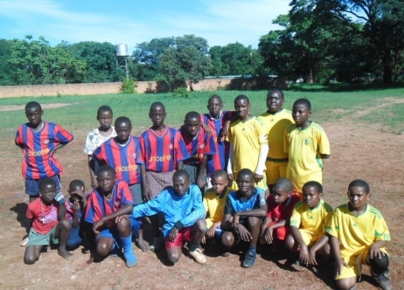
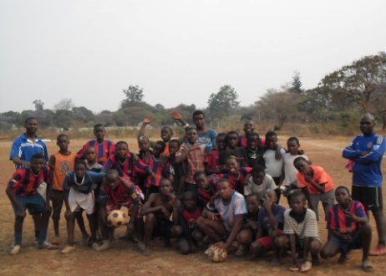



COMMUNITY STREET SOCCER CHAMPIONSHIP
HOSTED BY: BLUE STARS UNITED ACADEMY

THREE A-SIDE COMPETITION
PRIZES: CASH PRIZE AND TROPHY

AGE GROUP: 10YEARS – MADALAS

REGISTRATION FEE PER PERSON (K2) KIDS AND (K5) ADULTS
VENUE: NYUMBA YANGA COMMUNITY GROUND
DATE: 9th December 2013 TIME: 9HRS TO 1730HRS
FOR MORE INFORMATION CONTACT NUMBER +260979342768
REGISTRATION IS DONE AT CROSSROADS EVERY SATURDAY’S
IT’S HERE, BIGGEST STREET SOCCER COMPETITION

