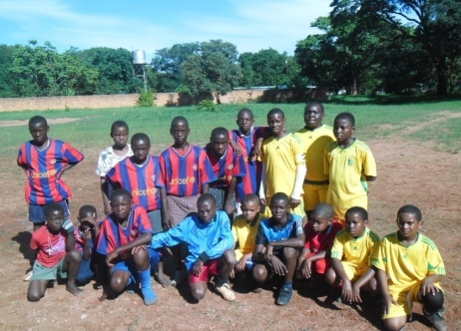
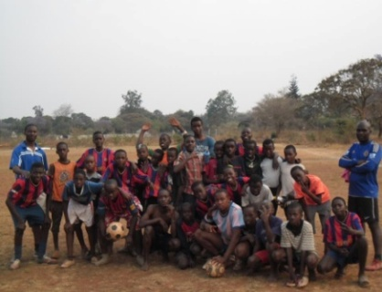
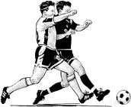
MATCHES

COMMUNITY STREET SOCCER CHAMPIONSHIP
HOSTED BY: BLUE STARS UNITED ACADEMY

THREE A-SIDE COMPETITION
PRIZES: CASH PRIZE AND TROPHY
AGE GROUP: 10YEARS – MADALAS
REGISTRATION FEE PER PERSON (K2) KIDS AND (K5) ADULTS
VENUE: NYUMBA YANGA COMMUNITY GROUND
DATE: 9th December 2013 TIME: 9HRS TO 1730HRS
FOR MORE INFORMATION CONTACT NUMBER +260979342768

REGISTRATION IS DONE AT CROSSROAD’S EVERY SATURDAY’S

IT’S HERE, BIGGEST STREET SOCCER COMPETITION

Match No:….
Team Colour  Under | VS | Team Colour  Under | Group | Goal | Team Colour  Under | VS | Team Colour  Under | Group | Goal
 |  |  |  | - |  |  |  |  | -
 | VS |  |  |  |  | VS
 |  |  |  | - |  |  |  |  | -
 | VS |  |  |  |  | VS
 | VS |  |  | - |  | VS |  |  | -
 | VS |  |  | - |  | VS |  |  | -
 |  |  |  |  |  |  |  |  | -
 | VS |  |  | - |  | VS
 |  |  |  | - |  |  |  |  | -
 | VS |  |  |  |  | VS
 |  |  |  | - |  |  |  |  | -
 | VS |  |  |  |  | VS
 |  |  |  | - |  |  |  |  | -
 | VS |  |  |  |  | VS
 |  |  |  | - |  |  |  |  | -
 | VS |  |  |  |  | VS
 |  |  |  | - |  |  |  |  | -
 | VS |  |  |  |  | VS
 |  |  |  | - |  |  |  |  | -
 | VS |  |  |  |  | VS
 |  |  |  | - |  |  |  |  | -
 | VS |  |  |  |  | VS
 |  |  |  | - |  |  |  |  | -
 | VS |  |  |  |  | VS
 |  |  |  | - |  |  |  |  | -
 | VS |  |  |  |  | VS
 |  |  |  | - |  |  |  |  | -
 | VS |  |  |  |  | VS
Matches Conformation: Tick: True Results:……. Not True Results:…….
Referees’ Name, Date and Signature:
Any Team Captain Name, Date and Signature:
Referees’ belief Matches Comment’s:
Match No:….
Team Colour  ADULTS | VS | Team Colour  ADULTS | Group | Goal | Team Colour  ADULTS | VS | Team Colour  ADULTS | Group | Goal
 |  |  |  | - |  |  |  |  | -
 | VS |  |  |  |  | VS
 |  |  |  | - |  |  |  |  | -
 | VS |  |  |  |  | VS
 | VS |  |  | - |  | VS |  |  | -
 | VS |  |  | - |  | VS |  |  | -
 |  |  |  |  |  |  |  |  | -
 | VS |  |  | - |  | VS
 |  |  |  | - |  |  |  |  | -
 | VS |  |  |  |  | VS
 |  |  |  | - |  |  |  |  | -
 | VS |  |  |  |  | VS
 |  |  |  | - |  |  |  |  | -
 | VS |  |  |  |  | VS
 |  |  |  | - |  |  |  |  | -
 | VS |  |  |  |  | VS
 |  |  |  | - |  |  |  |  | -
 | VS |  |  |  |  | VS
 |  |  |  | - |  |  |  |  | -
 | VS |  |  |  |  | VS
 |  |  |  | - |  |  |  |  | -
 | VS |  |  |  |  | VS
 |  |  |  | - |  |  |  |  | -
 | VS |  |  |  |  | VS
 |  |  |  | - |  |  |  |  | -
 | VS |  |  |  |  | VS
 |  |  |  | - |  |  |  |  | -
 | VS |  |  |  |  | VS
Matches Conformation: Tick True Results:……. Not True Results:…….
Referees Name, Date and Signature:
Any Team Captain Name, Date and Signature:
Referees belief Matches Comment’s:

