
BLUE STARS UNITED ACADEMY
House Number 9812/3/88, Nyumba Yanga off Alex Chola road, Lusaka, Zambia. P.O. Box 320326
Tel. +260979 342768, +260977 124534. Email: sinkalajkamps@yahoo.com , Isaacchawinga@yahoo.com.

3 November 2013

Embassy of the Federal Republic of Germany
5209 United Nations Avenue,
Lusaka, Zambia

Dear Ambassador Bernd Finke,
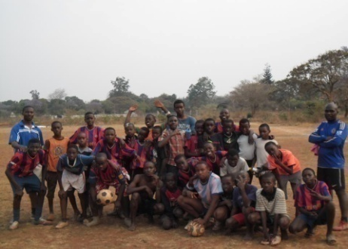
RE: Annually Football Tournament
With reference to the above subject matter, Blue Stars United Academy would like to be part of your annually football tournaments.
The main purpose is to nurture the talent of our youthful players, develop participation in sports with a particular focus on youth and children regardless of their religious group, ethnicity, nationality and language of the target group. As an Academy we also aim at enhancing knowledge and acceptance of using sport as a tool to address social issues like HIV/AIDS, child abuse and alcohol abuse.
Thank you for your time. May our good Lord bless you all the time. We look forward to your favorable response in this matter.
Yours faithfully

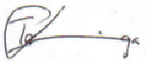
Managing Director: Associate Manager
Kampamba John Sinkala Isaac Chawinga
Contact No: 0979 342768 0977 124534


BLUE STARS UNITED ACADEMY
DATE: 15 September 2012
Sinkala and Chawinga

